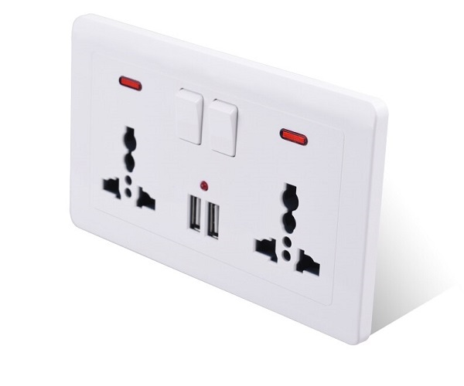

**Universal Wall Socket**

Over time, the evolution of wall sockets has brought remarkable improvements. These advancements reflect the ever-changing demands of day-to-day life. Wall socket designs have seamlessly adapted to the dynamic interactions of modern society, catering to the convenience of individuals in their routines. The concept of universality lies at the heart of these designs, ensuring that users can effortlessly engage with them.

Modern wall sockets are ingeniously crafted with diverse socket variants, such as USB ports, switches, GFCI outlets, and more, to cater to the multifaceted requirements of users. This array of options not only accommodates various devices but also harmonizes with the diverse technological landscape we navigate.

Moreover, contemporary wall sockets embrace an imperative aspect of safety – the inclusion of child protection mechanisms. These ingenious features act as a guardian, effectively shielding children from the potential hazards of electrical contact and averting any untoward accidents. This comprehensive approach to design not only enhances functionality but also prioritizes the well-being of all users, underlining the progressive nature of modern socket innovation.